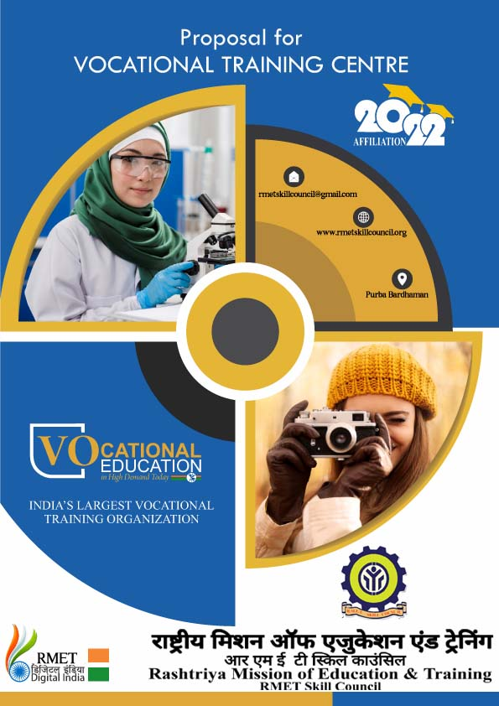

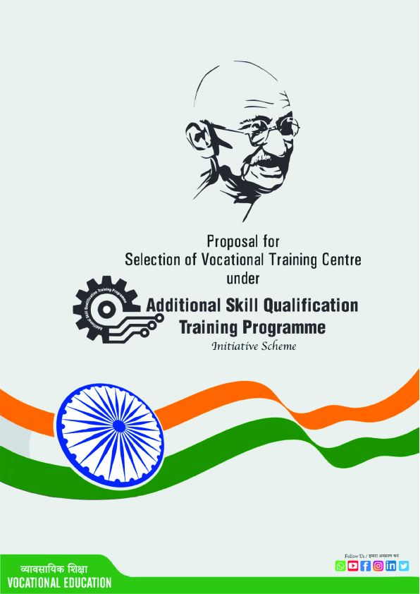

Rashtriya Mission of Education & Training ( RMET Skill Council ) is an ISO:9001:2015 certified organization for Vocational & Skill Education which is Governed by Rashtriya Siksha Vikash Abhijan, is an autonomous organization. Regd. Under Sec-60 Rule 69 of Director of Registration Govt of W.B. Dept. of Labour NCT (Delhi). Training Partner of NSDC (Govt. of india) & P.B.S.S.D Govt of W.B. Basic Training Provider Under Ministry of Skill Development And Entrepreneurship (Govt. of India).Approved By Ministry of Labour & Employment (NCS) & Dept. of M.S.M.E (Government of India). Accredited By Quality Council of India. During the British period, Wood’s Dispatch of 1854 contemplated pre vocational education. Indian Education Commission (1882), popularly known as Hunter commission also recommended the introduction of practical subjects in not only be an integral part of education but should centre round it. The Education commission (1964-66) also recommended a 10-year schooling and diversification into two streams- academic and vocational at plus 2.
Education is an endless process needed for the development of any nation. India being one of the developing country concentrates on four aspects of youth education as maximum present of youth are in our country and who are going to build this universe. The four central aspects of youth education are identified as : (1) lifelong learning; (2) an amplified version of basic education which includes pre-school, elementary and secondary level education; (3) links between formal and non-formal education; and (4) education for work.
First three are practiced by all the schools but the schools less concern the last education for work. This aspect can be affected by means of vocational training.
The role of education in facilitating social and economic progress has long been recognized. Education improves functional and analytical ability and thereby opens up opportunities for individuals and also groups to achieve greater access to labour markets and livelihoods. A better educated labour force is instrument of enhancing efficiency but is also an effective tool of widening and augmenting democratic participation and upgrading the overall quality of individual and societal life.
Skill and knowledge are the engines of economic growth and social development of any country. Countries with higher and better levels of knowledge and skills respond more effectively and promptly to challenges and opportunities of globalization. India is in transition to a knowledge based economy and its competitive edge will be determined by the abilities of its people to create, share and use knowledge more effectively. This transition will require India to develop workers into knowledge workers who will be more flexible, analytical, adaptable and multi skilled.
In the new knowledge economy the skill sets will include professional, managerial, operational, behavioural, inter personal and inter function skills. To achieve this goals, India needs flexible education and training system that will provide the foundation for learning, secondary and tertiary education and to develop require competencies as means of achieving lifelong learning. RMET Skill Council is trying to make the vocational training programme successful all over India to uplift Youth.

Introduction
Skills, Knowledge and innovation are important driving forces of economic growth and social development in our country and country with higher levels of skill, adjust more effectively to challenge and opportunities in the global economy. India has had relatively strong economic performance in the past decade. There have some drawback to uphold the current situation of skill development and job creation. To overcome this pressure vocational education is the alternative option for the social and personal development. Vocational education can increase the socio-economic development of the developing country like India.
Democratizing Vocational Education by taking it to the doorsteps of the learners. Providing access to quality education to all those who seek it irrespective of age, region or formal qualifications. Offering need-based academic programmes by giving professional and vocational orientation to the courses. Promoting and developing Vocational education under Skill Enhancement Training Programme (SETP) in India Setting and maintaining standards in skill based vocational education in the country.
Our Mission
Towards becoming a ‘Centre of Excellence’ in only regular courses by offering Quality Training Programmes to meet the current and emerging needs of the adult population, by widening the access to vocational training and by functioning as a catalyst to bridge social, economical and to be a major part in developing India.
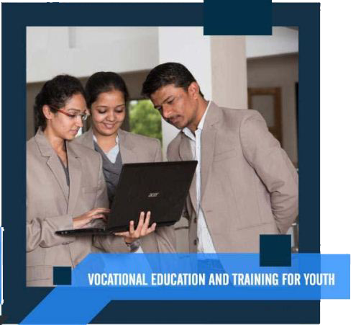
Our Vision
RMET Skill Council shall make available innovative, socially relevant educational provisions that are Learner-centred, seamless and are of High quality by employing appropriate vocational training equity in education, sustainable social transformation and composite national development.

Recognition
Rashtriya Mission of Education & Training (RMET Skill Council ) is an ISO: 9001:2015 certified organization for Vocational & Skill Education which is Governed by Rashtriya Siksha Vikash Abhijan, Certificate of Registration under Section 60 and Rule 69 registered in Book IV Volume Number 1903-2016, page from 181425 to 181451 being no 190307682 / 2016 is an autonomous organization. Regd. under Dept. of Labour NCT (Delhi). Training Partner of NSDC (Govt. of India) & P.B.S.S.D Govt. of W.B. Basic Training Provider Under Ministry of Skill Development And Entrepreneurship (Govt. of India).. Accredited By QualityCouncil of India. And Rashtriya Mission of Education & Training (RMET Skill council) also all courses registered in Book IV Volume Number-1903-2021, page from 26614 to 16677 being No. 190300736 / 2021. Approved By Ministry of Labour & Employment & Dept. of M.S.M.E (Government of India)
Sector/Industry
Self employment course provide student with an introductory knowledge and understanding of self-employment and requirements of success. the courses is designed for student wishing to consider self-employment on further study in area of self-employment and progression routes. Providing access in 30+ sectors is to make quality vocational education to all those who seek it irrespective of age, region or formal qualifications.
RMET Skill Council offers vocational skill courses under RSVA in various sectors viz, (1) Advertising and Media Industry (2) Agriculture and Allied Technology (3) Art, Drawing and Painting (4) Automobile Sector (5) Aviation Sector (6) Banking, Financial Services and Insurance, (7) Beauty culture and Spa (8) Building and Construction Technology (9) Chemical Industry (10) Computer and Information Technology (11) Cookery, Bakery, Confectionary and Food Processing (12) Cottage Induatry (13) Cutting, Tailoring, Dress Making and Fashion Designing (14) Electrical & Electronic sector (15) Entrepreneurship & Professional Skill Sector (16) Fire & Safety Sector (17) Fishery Science Sector (18) Foot-wear Technology (19) Gold Appraiser (20) Handicrafts Sector (21) Health and Paramedical Sector (22) Hospitality Sector (23) Leather Industry (24) Logistics and shipping Management Sector (25) NGO Management (26) Photography (27) Plastic Industry (28) Printing Technology (29) Renewable Energy (30) Refrigeration and Air Conditioning Sector (31) Secretarial Practice Sector (32) Teacher Training Sector (33) Telecom (34) Textile Technology (35)Veterinary Sector (36) Yoga Sector.

Syllabus / Curriculum
Effective course design begins with understanding who your students are, deciding what you want them to learn; skill oriented; determining how you will measure student learning; and planning activities, assignments and materials that support student learning. The course/curriculum is previewed and reviewed by the faculty as well as outside media experts and edited or modified, wherever necessary, with the supervision of members of RMET Skill Council before they are finally forwarded to the Vocational Training Centre.
Board Examination
RMET Skill Council has sole right to fix the dates and venue of examination and intimate to Vocational Training Centres through the Controller of Examinations, RMET Skill Council well in advance. The Hall Tickets, Question Papers, Answer sheets, Invigilator ID, Student Registration Form, Internal Assessment Report and Practical Report and other required stationery items for the conduct of examinations shall be sent by RMET. RMET shall arrange to conduct the examinations as per the regulations and get the performance of the students evaluated and award certified skill Diploma or Certificate to the successful candidates.

Issue of Certificates
Certified Skill Certificate for Diploma course / awards for the programme completion will be issued by RMET Skill Council, and it will be distributed through the Zonal offices to vocational Training Centres and to the students.

Introduction
Skills, Knowledge and innovation are important driving forces of economic growth and social development in our country and country with higher levels of skill, adjust more effectively to challenge and opportunities in the global economy. India has had relatively strong economic performance in the past decade. There have some drawback to uphold the current situation of skill development and job creation. To overcome this pressure vocational education is the alternative option for the social and personal development. Vocational education can increase the socio-economic development of the developing country like India.
Democratizing Vocational Education by taking it to the doorsteps of the learners. Providing access to quality education to all those who seek it irrespective of age, region or formal qualifications. Offering need-based academic programmes by giving professional and vocational orientation to the courses. Promoting and developing Vocational education under Skill Enhancement Training Programme (SETP) in India Setting and maintaining standards in skill based vocational education in the country.

Our Mission

Towards becoming a ‘Centre of Excellence’ in only regular courses by offering Quality Training Programmes to meet the current and emerging needs of the adult population, by widening the access to vocational training and by functioning as a catalyst to bridge social, economical and to be a major part in developing India.

Our Vision

RMET Skill Council shall make available innovative, socially relevant educational provisions that are Learner-centred, seamless and are of High quality by employing appropriate vocational training equity in education, sustainable social transformation and composite national development.

Aim & Objective

We provide students a thorough training that will allow them to build up a professional career in their field of interest.
• The mission aims at the empowerment of youth, through imparting them technical skills and encouraging their self-economical reliability.
• To empower youth through income generating skills and entrepreneurship.
• Promote the youth to and full participation, on the basis of equality with youth in economic opportunity and education.
• To develop and disseminate strategies that can be used in analysing the local situation and developing innovative skills at the local level.
• To facilitate economic development, suitable skill up gradation trainings will be given to the youth.
• To provide quality Training to inculcate self-employment among the youth.
• To encourage sustainable development that will create an economic viability for present and future generations.
• To facilitate the development of skills that increase vocational and training Opportunities.
• The values, attitudes and skills, necessary to change behaviour in regard to natural resource management.
Application Letter
To,
The Chairman,
Rashtriya Mission of Education & Training
RMET Skill Council.
Sir/Madam,

Subject :- Application for Registration as Vocational Training Centre under Skill Enhancement Training Programme (SETP) Initiative Scheme.
We, the undersigned, hereby apply for Registration as Vocational Training Centre under (SETP) Initiative Scheme. We would like to state that information provided by us is true to the best of our knowledge and belief and we understand that we are liable for action under the law for any false information or document produced by us. We also understand that Rashtriya Mission of Education & Training (RMET Skill Council) or any other representative of RMET shall be free to investigate on its own into the correctness of information furnished by us in this application and/or call for any further information in this regard from us.
During such investigation or at any subsequent stage Rashtriya Mission of Education & Training (RMET Skill Council) may refuse to issue the letter of registration or if already issued may cancel the same and we shall stand debarred for applying as Vocational Training Centre under Skill Enhancement Training Programme (SETP) Initiative Scheme.
Date:- From,

Signature of the Centre Co-ordinator
Name & Designation:-

Contact No.:-
E-mail:-

Procedure For New Vocational Training Centers
The prospective vocational Training Center needs to apply to RMET Skill Council(Unit of Rashtriya Siksha Vikash Abhijan) in prescribed application form, duly filled in all respect, accompanied along with photographs of the building proposed, Registration of society, Map of the building, infrastructure details, Faculty details and non-refundable processing fee.
The fee and sharing pattern is as follows :
- Affiliation fee – (Non-refundable)
- Minimum 5 courses can be applied in any sector / Industry.
- If exceeds 5 courses, Additional Course Fee-Rs. 3,000/- (per course , Non-refundable)
- Renewal Fee- Rs. 8,000/- ( per two years, non-refundable)
- VTC Name Change Fee- Rs5000/- (Non-refundable)
- VTC address change fee – Rs. 5000/- (Non refundable)
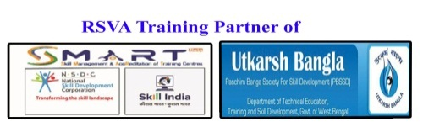
ISO: 9001: 2015 certified
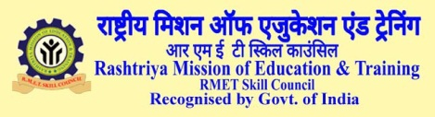

An ISO 9001:2015 certified Autonomous Examination & Certification Body
to promote Skill Education, Training & Research Programme in all over India.
Initiative of Rashtriya Siksha Vikash Abhijan.
Particulars to be furnished by the Management of the Voluntary Organization / Institution seeking permission to conduct vocational training courses on the pattern of Self Employment Vocational Training Scheme leading to Affiliation Rashtriya Mission of Education & Training (RMET Skill Council).

Instruction :-
- Please refer the guidelines and instruction carefully.
- Fill all the relevant details in the sections below.
- Enclose the particulars of proposed vocational training centre.
01. | Name of the Vocational training centre (Proposed)
 | a) Address
 | b) Village / Town
 | c) Post Office
 | d) District
 | e) PIN Code
 | f) State
 | g) Contact Number
 | h) E-mail Id
 | i) Website
 | j) Nearest Railway Station & distance in Kms. from institute
 | k) Nearest Bus stop & distance in Kms. from institute
02. | a) Name of the Centre Co-ordinator
 | b) Contact Number of Co-ordinator
 | c) Name of the Centre Head
 | d)Contact Number
03. | Name of the trust / society/ pvt ltd.
04. | Registration Certificate No./ Trade Licence No.
05. | Name and address of the Co-ordinator / correspondent with qualifications ( Attach six copies of the passport size photographs) | (Enclosed)

ISO 9001:2015 certified

06. Details of Vocational Training Courses to be offered
COURSE CODE |  |  | NAME OF THE COURSE |  |  |  |  | DURATION
07. |  |  | Buildings plinth area of the building. No. of Rooms / sheds / laboratories / workshops with measurements Attach copy of sale/lease deed |  |  |  |  | (Enclosed)
08. |  |  | Equipment needed suiting to the Syllabus |  |  |  |  | (Enclosed)
09. |  |  | Furniture : List of furniture required with details |  |  |  |  | (Enclosed)
10. |  |  | Library Books |  |  |  |  | (Enclosed)
11. |  |  | Staff Structure |  |  |  |  | (Enclosed)
12. |  |  | Number of qualified Vocational Courses Teaching Staff Proposed with qualifications |  |  |  |  | (Enclosed)
13. |  |  | Recruitment of Staff on permanent/part-time basis |  |  |  |  | (Enclosed)
14. |  |  | Details of Affiliation fee paid (Account ) in favour of Rashtriya Mission of Education & Training , Purba Bardhhaman, West Bengal.  Name of the Bank:- STATE BANK OF INDIA  Name of the Branch :- KHANDAGHOSH BRANCH  IFSC Code :-SBINOO61651  Account No.:- 39961238580
(Please attach separate sheet wherever required)

Signature of the Principle /
Centre Co-ordinator of the Institution with Seal

15.
Undertaking
We have fully understood the conditions prescribed by the RMET Executive Board of Vocational Courses and we hereby undertake to fulfil all the conditions within the time limits stipulated and if such fulfilment has not been done, the proposals for opening of Vocational Courses in the RMET may be dropped at any stage and the affiliation / recognition sanctioned will be withdrawn. The management undertakes to pay the salary and other emoluments to the teaching and non-teaching staff without any aid from the RMET now as well as in future.

Place:
Date: Signature of the Principle /
Centre Co-ordinator of the Institution with seal
16. Inspection by Three Main Committee :
The Board of RMET shall arrange to conduct Inspection of the Proposed centre to examine its viability. The inspection committee shall consist of Zonal officer and any person Appointed by the RMET.
ADDITIONAL ACCOMODATION (in Sq.ft)
16. | Principle’s Room |  |  |  |  | 200
17. | Office Room |  |  |  |  | 250
18. | Library and Reading Room |  |  |  |  | 350
19. | Staff Room |  |  |  |  | 200
20. | Theoritical class room per course |  |  |  |  | 400
21. | Practical Room per course |  |  |  |  | 400
22. | Toilets With Flushing ……. For Boys 2, …. For Girls 2 …… For Staff 1
23. | Water facility with sump, overhead tank and pump.
24. | purified drinking water facility with proper storage.
ADMINISTRATIVE AND MINISTERIAL STAFF
Sl. No. |  | Name of the Staff Member |  | Age | Designation |  | Qualification

PUBLIC NOTICE
Rashtriya Mission of Education & Training (RMET Skill Council) is an ISO 9001:2015 certified institution governed by Rashtriya Siksha Vikash Abhijan which is registered under the Govt. Of West Bengal. The organization established for the development of literacy and skill education in West Bengal and all other states of India under the guidelines of National Education Policy,1986 and Programme Of Action,1992, Govt. of India. The institution follows the national curriculum framework to improve the quality of education.
Rashtriya Mission of Education & Training (RMET Skill Council) has designed the courses according to its own rules and regulations. The courses has been designed for improving the literacy percentage and development for skill education in India and make people to become self-depended.
Rashtriya Mission of Education & Training (RMET Skill Council) offer some different types of professional courses and educational programme for awareness for poors and distress who are basically financial weak in the society. After completing any of the courses student can be self-depended or may get job in private sector. All the courses are awareness programme based on vocational education for the students. These courses are not Govt. Courses. ‘RASHTRIYA MISSION OF EDUCATION &TRAINING’ does not provide any type of Degree Course. So, these courses are not any degree. These are only skill developing programme for the nation. The students will bear a nominal fee to get the education or training from any RMET Study Centre’s all over India. ‘RASHTRIYA SIKSHA VIKASH ABHIJAN’ is a Non-Profitable organization. The Participant of our courses mainly Health Care Education, Paramedical Technology, Patient Care Education awareness programme could not use the word ‘Dr.’ (Doctor) before his/her name and could not use any type of medical related logo/symbols. They could not provide any type of medical certificate. They could not treat any emergency, surgical and delivery patient. They have no right to give prescription to the patient by their name. They can be working as a rural health worker or rural health assistant under any Registered Govt. Doctor or Regd. Physician. They could provide First-Aid service among the rural people in absence of Doctors for Primary Health Care and refer to any nearest Govt. Hospital (if require).
We Kindly request to you to verify the credentials of the certificate and its validity before joining the courses offered by Rashtriya Mission of Education & Training (RMET Skill Council). Do not believe in any kind of false promises, and in case of doubt kindly call us or mail us or come in person and check the original motive behind the promotion of the courses.
In case of any dispute it shall be resolved by the committee appointed by Rashtriya Mission of Education & Training (RMET Skill Council) through the Arbitration and Reconciliation Act 1996. The decision of the arbitrator shall be final and binding on all parties. Direct court intervention is not permissible.

Declaration
I hereby declare that we will abide the Rules and Regulations / instructions prescribed by Rashtriya Mission of Education & Training (RMET Skill Council) then and there for the conduct of VTC if any deviation is noticed in my Vocational Training Centre in following the norms prescribed, I accept the cancellation of recognition at any time.
Place:
Date:- Signature of the Principle /
Centre Co-ordinator of the Institution with Seal

LIST OF ENCLOSURES
- Affiliation procession fee.[Account in favour of Rashtriya Mission of Education & Training (RMET Skill Council)]
- Centre Co-ordinator’s (VTC) resume with Passport size photo.
- Centre Photos (lab, Class room, reception, cabin & front view of the centre photos).
- Copy of the certificate of registration under trust/society/Pvt. Ltd. /section 8 company/Trade.
- List of books in library with relevant sector, if any.
- Tools and requirements details about relevant sector, if any.
- Copy of full time and part time staff with relevant details.
- Title deed of the property or proof of lease or building agreement.
- Permanent Account Number under income tax act provision, if any.
- Power of attorney/board resolution in case of company/trust.
- Other activities and annual report about existing students, if any.
- Electricity Consumption Bill (Recent one) for institution.
- Institution building stability with planning details.
- Fire and safety certificate in the name of the Institution.
- Health and sanitary Certificate in the name of the Institution.
- Tie-up/ Noc for Practical/Internship from concern authority.

Address for the proposal to be send
The hard copy of this proposal can send by e-mail to below mentioned address and must be send the hard copy of proposal by Registered post with all necessary documents.

An ISO 9001:2015 certified Autonomous Examination & Certification Body
to promote Skill Education, Training & Research Programme in all over India.
Initiative of Rashtriya Siksha Vikash Abhijan.

Secretariate Office :-Rashtriya Siksha Vikash Abhijan
Mollaroad, Khandaghosh, Purba Bardhaman,W.B.-713424
Contact No.:-9733362672 / 9093312782. Email ID : rmetskillcouncil@gmail.com
Website : www.rmetskillcouncil.org

Central Programme Office: Vinayak Residency, Block-B,Flat No.F/1,
Noapara, North 24 Paraganas, Kolkata-700157

